DR. AMBEDKAR COLLEGE, DEEKSHABHOOMI, NAGPUR
DEPARTMENT OF LAW
Academic Session - 2022-2023

NAME OF THE PROGRAMME: | Human Rights Day celebration- Article writing competition by Human Rights Cell
NAME OF THE PROGRAMME SUPERVISOR | Prof. Dr. H.V. Menon
NAME OF THE PROGRAMME CO-ORDINATOR: | Dr. Vaishali A. Sukhdeve
DATE AND DAY: | 10th December 2022
TOTAL NUMBER OF PARTICIPANTS: | 21 STUDENTS: 12 GIRLS; 09 BOYS
VENUE: | Online submission
LINK FOR REGISTRATION: | https://forms.gle/CNGXieqLvm71eHxXA

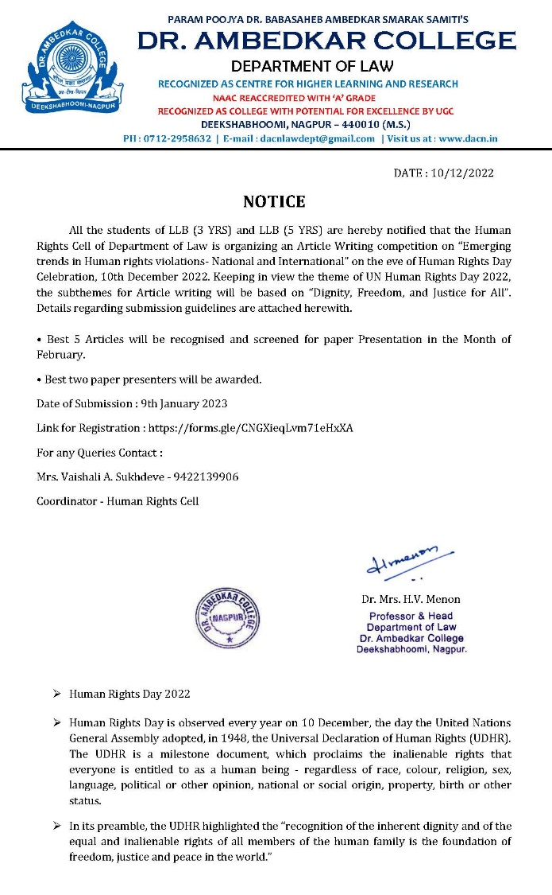 | 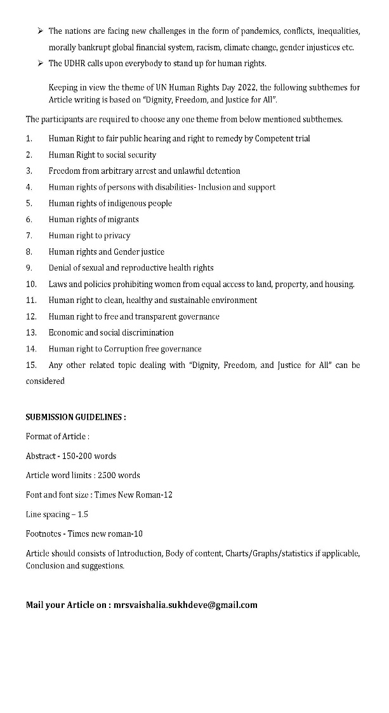

Department of Law through the Human rights Cell organized the Article writing competition for all the students of LLB (3 YRS) and LLB (5 YRS) on the topic “Emerging trends in Human rights violations- National and International” on the eve of Human Rights Day Celebration on 10th December 2022. Human Rights Day is observed every year on 10 December, the day the United Nations General Assembly adopted, in 1948, the Universal Declaration of Human Rights (UDHR). The UDHR is a milestone document, which proclaims the inalienable rights that everyone is entitled to as a human being - regardless of race, colour, religion, sex, language, political or other opinion, national or social origin, property, birth or other status. In its preamble, the UDHR highlighted the “recognition of the inherent dignity and of the equal and inalienable rights of all members of the human family is the foundation of freedom, justice and peace in the world.
Keeping in view the theme of UN Human Rights Day 2022, the subthemes for Article writing were based on “Dignity, Freedom, and Justice for All”. Details regarding submission guidelines were shared with the students. Best three papers were selected. Among them were Ms. Sanika Duragkar who wrote her article on the topic “Human rights of the migrants”, Mr. Nihar Mehar, researched on the topic “Dignity, freedom and Justice for all” and Mr. A.A. Khan’s paper was on “Human rights and Gender justice”. These student’s research articles were considered as the best papers. As per the registration link total 21 responses were received from the students of different semesters. Dr. Mrs. Vaishali A. Sukhdeve organised this competetion under the able guidance of the Head of Department of Law, Prof. Dr. H.V.Menon.

IMAGES OF REGISTRATIONS AND ARTICLES RECEIVED

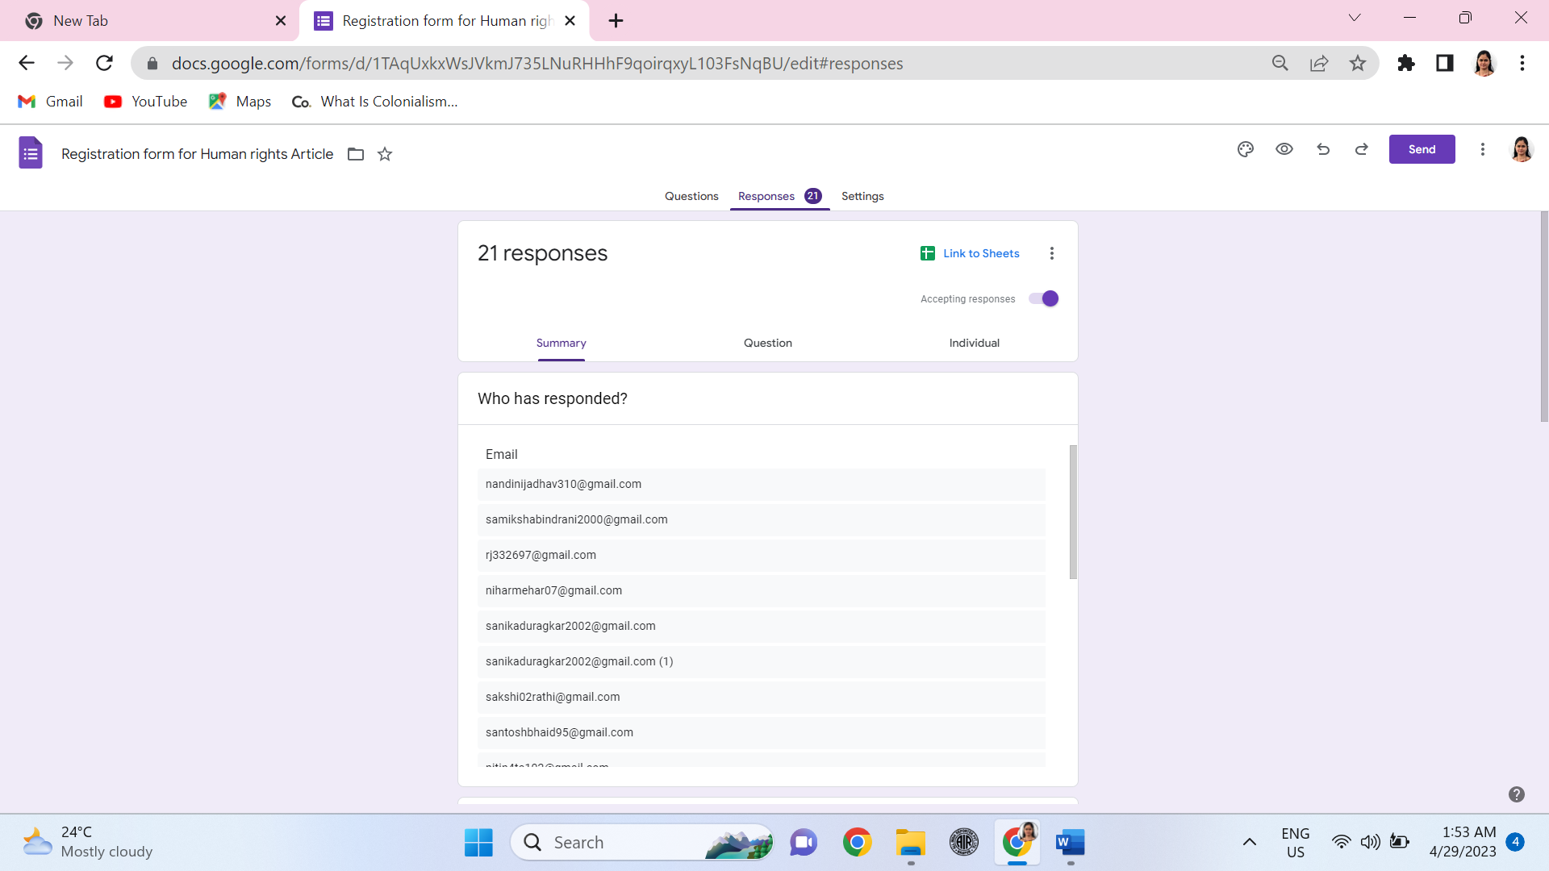 | 